1. **Agenda**:
   1. Setting **Profit Targets** with Morning Star Pattern.
   2. Which trades we should take and which we should not.  
      Let’s analyse the situation.
2. 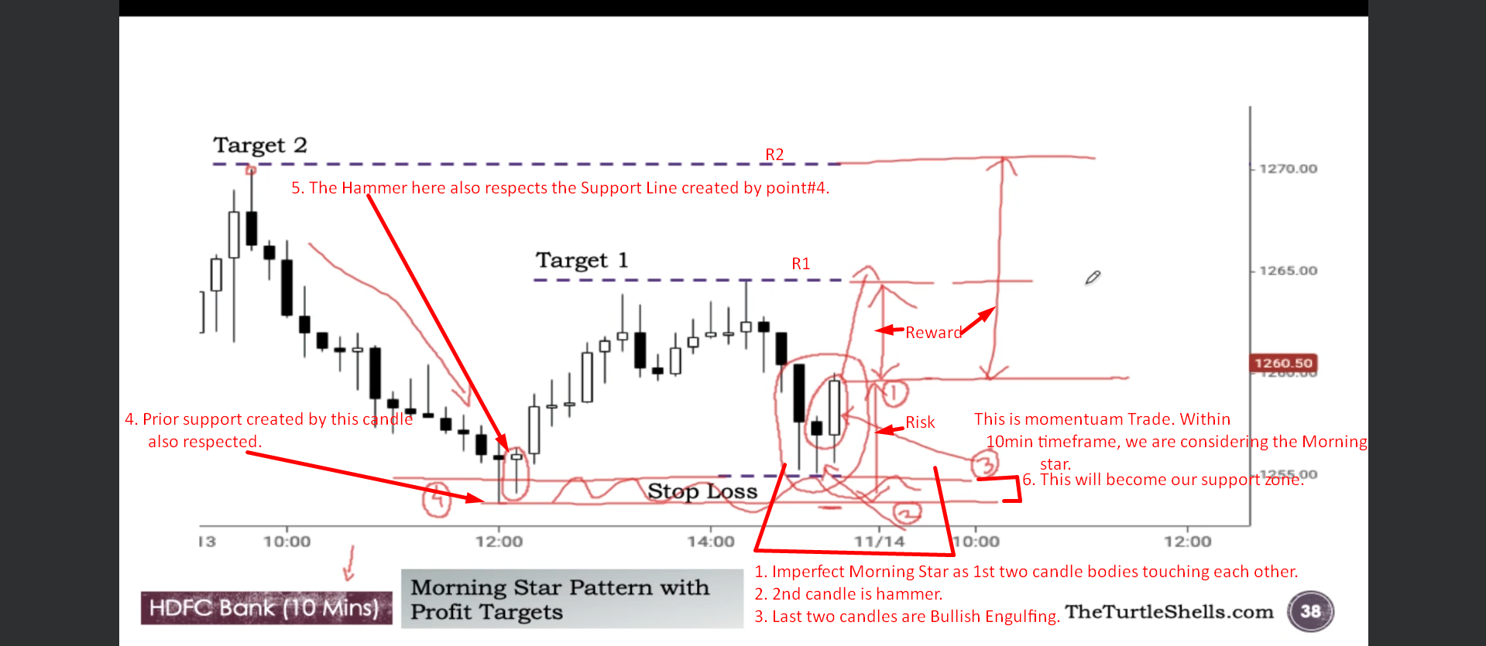  
   Above when considering the R1, the reward to risk is 1 to 1 and considering R2, it is almost 2:1.
3. 